

CONTACT CENTRE WEEKLY REPORT

20 NOVEMBER 2025

3. CONTACT CENTRE ACTIVITY REPORT
TARGET DATE | WEEKLY OBJECTIVE | WEEKLY PROGRESS | ACHIEVED/NOT ACHIEVED | CHALLENGES | MITIGATION | NEXT WEEK OBJECTIVE
30.11.25 | Engage NOC, with a view to improve faults turnaround times to within 48hrs from logged date. | 85 of 91 faults (constituting 93%) were resolved during the period under review, with 83 of these (constituting 98%) resolved within 72hrs.  6 faults remain outstanding as at end of week.  1 being a faulty convertor issue, 1 being a UTP issue, 1 being a faulty WIFI Router issue & 3 being fibre cable related faults. | Achieved and ongoing | Steady progress on fault resolution for both Harare and Western Region Teams, despite current resource constraints. | By optimising workflows and leveraging cross-regional support, we’re steadily reducing resolution times | Continue engaging NOC to reduce fault turnaround times to 48 hours from the logged date.  Maintain proactive follow-up with the Operations Team to strengthen power backup on critical nodes
30.11.25 | Resolve all reported faults | 85 faults were resolved during the period under review. | Ongoing  Achieved 93% | Power backup gaps on certain nodes: Currently identifying and addressing gaps to strengthen reliability and improve service delivery. | Proactively manage the faults priority list and maintain close liaison with the Operations Team to ensure alignment on urgency and delivery timelines. | To continue tracking all longstanding faults (72 hours and above) with a target to resolve them within 48 hours
30.11.25 | Attend to all customer queries within 24 hours | 1 713 Contact Centre traffic was recorded during the period under review.  All enquiries were responded to within 24 hours. | Achieved | The department is operating with staffing shortages—only one agent per shift across three shifts—and lacks adequate tools, including enough new computers for each contact center agent; addressing these gaps will boost efficiency and service quality.. | Attend to all customer queries within 24 hours.  Operating with the c available resource while awaiting MP1 approval for two additional staff | Optimise and strategically allocate existing resources to maximize output.
30.11.25 | Improve Communication with clients – on all enquiries and feedback within 24hrs. | Client updates continue at least 2 times a day, on various platforms – email, WhatsApp, calls. | Achieved & Ongoing | Intergration of communication platforms. | Optimal use of all the communication platforms | To raise RFP for addition contact centre line and replacement of cellphones.  To conduct Customer and Suppliers Survey.
30.11.25 | 365/24/7 Contact Centre | 24/7 Contact Centre was rolled out Thursday 7 November; 2024. | Achieved and ongoing. |  | Currently the Contact Centre is being manned 24/7 | Continuous engagement with the Tech & NOC Teams concerning fault updates.
 | Upgrade the Contact Center to world class standards | Upgrade the Contact Centre | On-going: Consultation | The department requires a state-of-the-art, digitally driven contact center system to replace the current largely manual processes. | Maximizing the impact of our current resources as we, stay focused on delivering an increasingly customer-centric experience. | Continually engaging key stakeholders for a system-based contact centre.
30.11.25 | Cross Selling | Cumulative Figure  (To date)  Visits – 6  Customers engaged on products and services – 395  Requests for quotations on the behalf of customers send to Retail Sales – 2080 | On-going | Inadequate working tools – the need for at least 6 new computers. | Making use of available communication channel  *1 Direct Line  *1 WhatsApp Line  *Email platform | Continue with Cross Selling

CONTACT CENTRE WEEKLY FAULTS SUMMARY

WEEK | OPENING BALANCE | NEW FAULTS RECEIVED | TOTAL FAULTS | RESOLVED FAULTS | CLOSING BALANCE – PENDING FAULTS | RESOLVED WITHIN  3 DAYS (72HRS)
1 | 28 | 69 | 97 | 82 | 15 | 89%
2 | 15 | 72 | 87 | 73 | 14 | 96%
3 | 14 | 77 | 91 | 85 | 6 | 98%

FAULTS MANAGEMENT SUMMARY

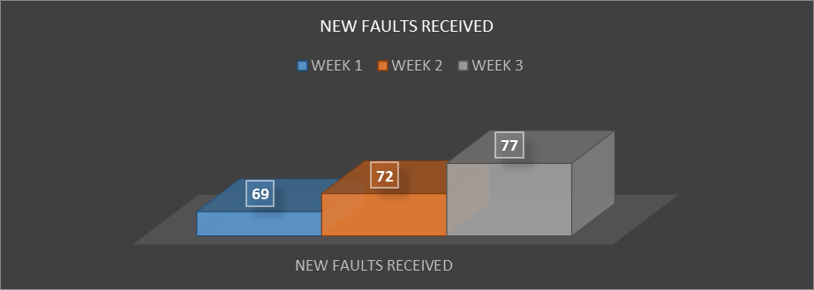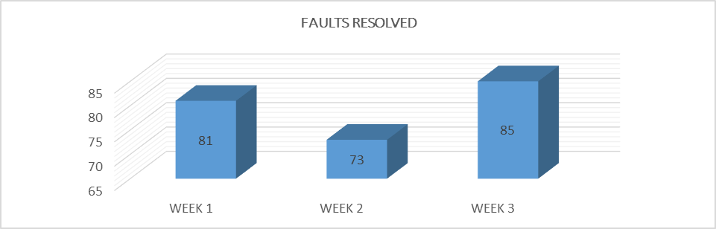

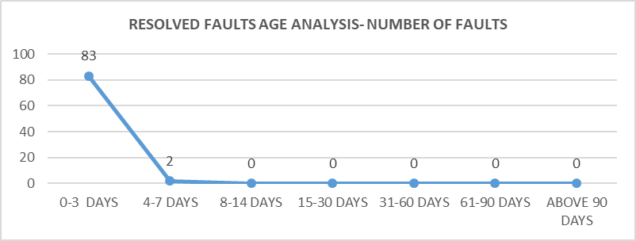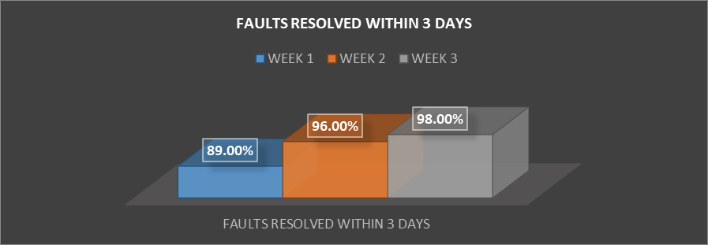

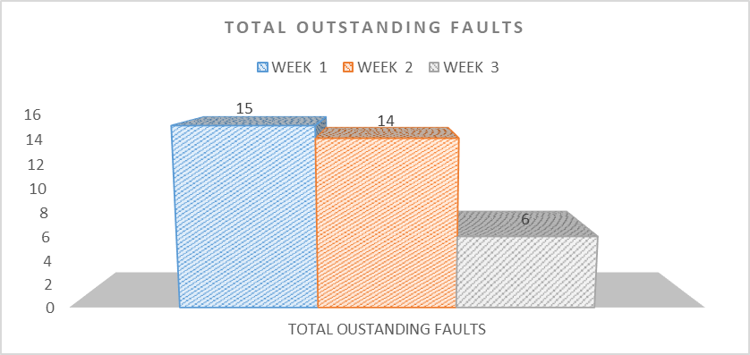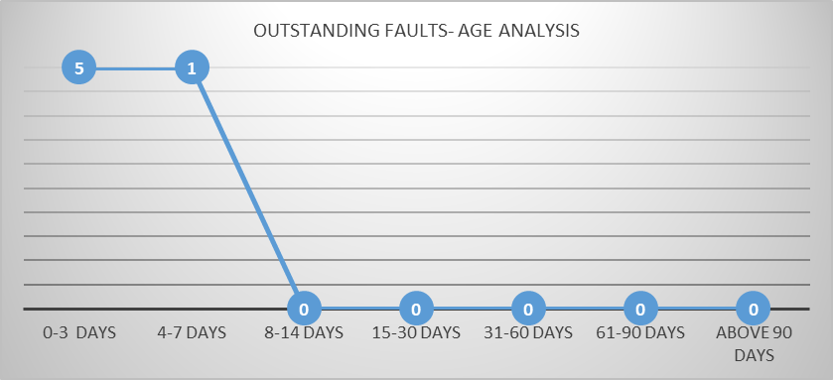

WEEKLY CONTACT CENTRE TRAFFIC SUMMARY

TRAFFIC – BY SHIFT

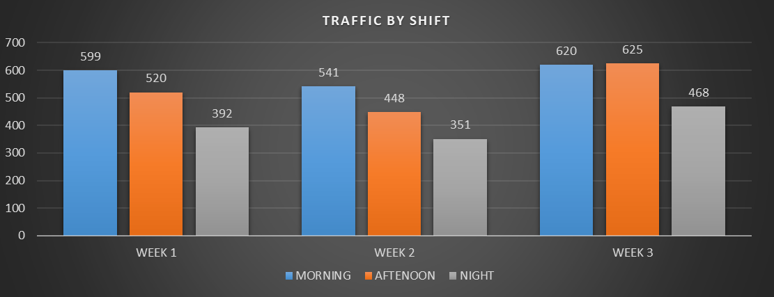

- The Contact Centre resumed the 24-hour Shift on Thursday 7 November 2024.
- The Traffic by Shift for this week was as follows:

SHIFT | TRAFFIC IN NUMBERS
MORNING SHIFT | 620
AFTERNOON SHIFT | 625
EVENING SHIFT | 468
TOTAL TRAFFIC FOR ALL SHIFTS | 1713

TRAFFIC – BY CHANNEL

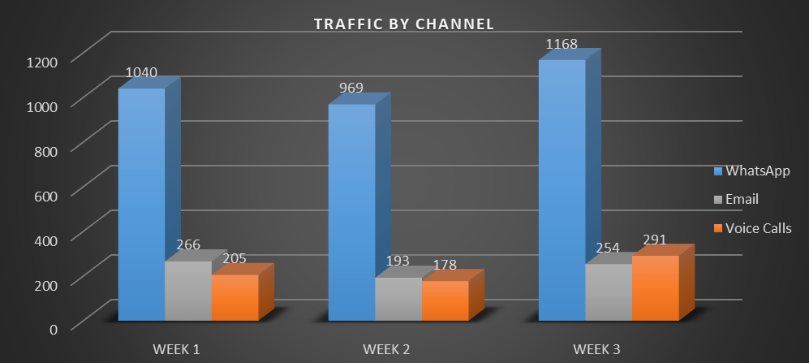

The Contact Centre Traffic by Channel for this week was as follows:

WHATSAPP CHANNEL | E- MAILS | VOICE CALLS | TOTAL TRAFFIC IN NUMBERS
1,168 | 254 | 291 | 1713

